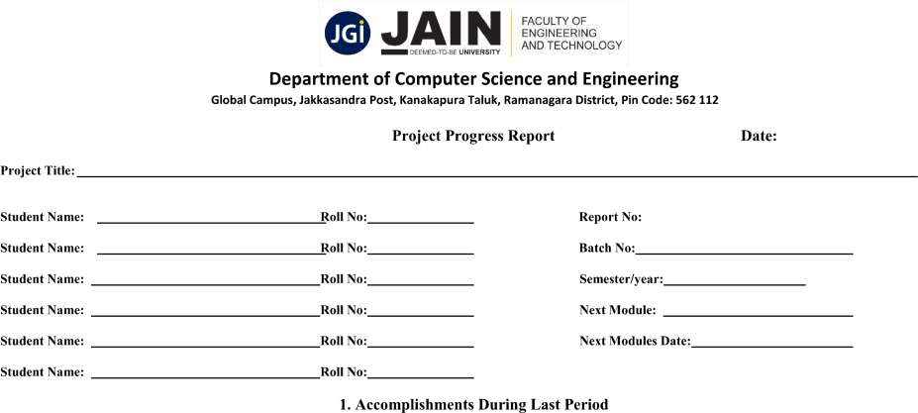

Accomplishment during last periods
1. | Completed the requirement analysis phase, identifying key features such as movie search, note-taking, and categorization. | 2025-03-22 | completed
2 | - Finalized the UI/UX design, ensuring a user-friendly interface with intuitive navigation.  - Integrated the OMDb API for real-time movie data retrieval. | 2025-03-30 | completed
3. | Implemented local data storage to save user notes and preferences, ensuring data persistence across sessions. | 2025-04-04 | completed

4. | Developing secure login mechanisms to protect user data and enable personalized experiences. |  | 2025-04-15
5. | Implementing cloud-based storage solutions to allow users to access their personalized movie data across multiple devices seamlessly. |  | 2025-04-25
6. | Developing an AI-driven recommendation system that suggests movies based on user preferences, viewing history, and ratings.
7. | Conducting comprehensive testing to identify and fix any bugs, ensuring the app's stability and performance.
